This 16-hour curriculum is organized into eight lessons, each lasting two hours. Every lesson follows a consistent four-part structure: 30 minutes of Basic material, a 30-minute interactive "break mission”, 30 minutes of advanced material, and a concluding 30-minute competition to apply the day's concepts.
At the end of every competition, I highly recommend giving two titles: “King of The Model” and “The Rising Star" where the prior goes to the winner of the competition and the latter is more versatile and goes to a student chosen by the teacher. The student could be someone who has gone through major advancements, someone who is trying really hard or needs motivation or just someone who you want to give a shout-out to.

Lesson 1: UI Navigation And Basic Sketching + Shaping
Min 0-30: Basic sketching:
- Sketch features:
- Line
- Corner Rectangle
- Center Point Circle
- Dimension
- Construction
- Constraints:
- Coincident
- Vertical
- Horizontal
Min 30-60: Sketch exercise as shown below:
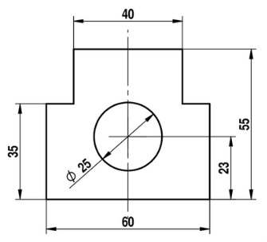
Min 60-90: More basic sketching:
- Sketch features:
- Point
- Constraints:
- Parallel
- Equal
- Shaping:
- Extrude - New + Remove
- Blind
- Up to dace
- Through all
- Starting offset

Min 90-120: Race to the CUBE:
All the student will be given a challenge - to model the cube shown below, where the cube size are given (50mm*50mm*50mm) and the wall thickness (offset) is known (5mm). The first student to model the cube as asked will be declared the winner and the “king of the model" of that lesson.
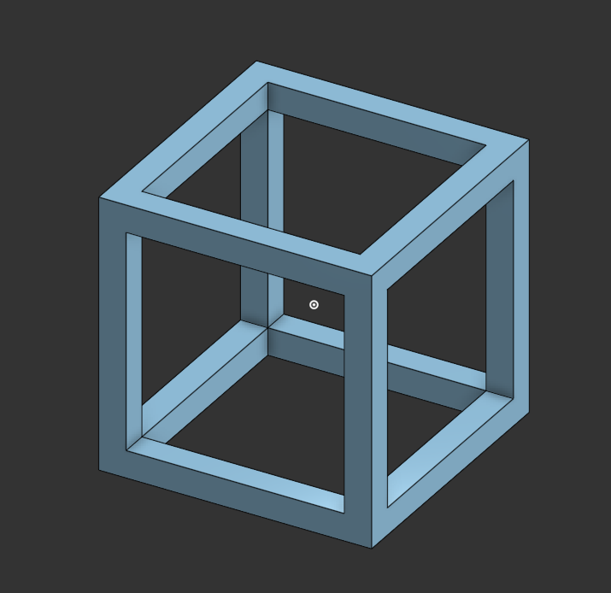

Lesson 2: Advanced Sketching And Shaping
Min 0-30: Advanced sketching:
- Sketch features:
- 3 Point Arc
- Midpoint Line
- Center Point Rectangle
- Center Point Arc
- Constraints:
- Perpendicular
- Midpoint
- Concentric
- Shaping:
- Thicken
Min 30-60: Part exercise as shown below:
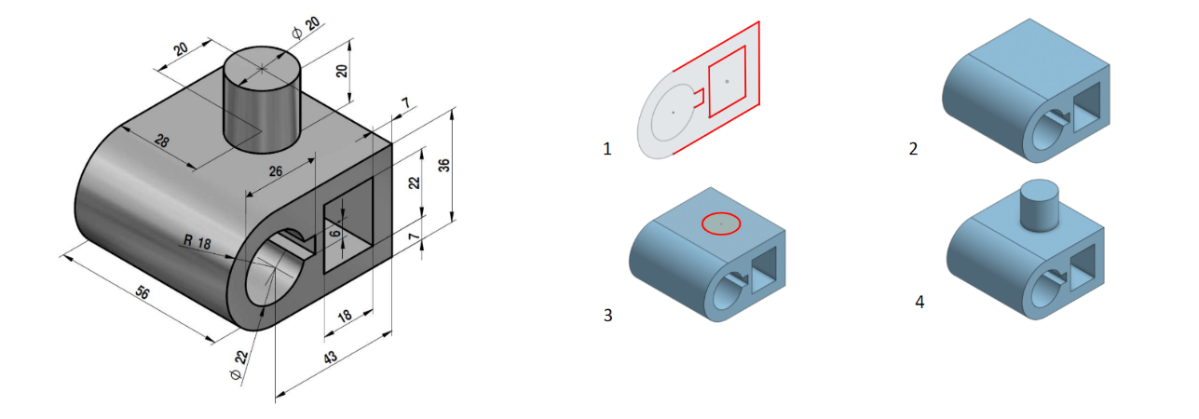
Min 60-90: More Advanced sketching:
- Sketch features:
- Mirror
- Linear Pattern
- Circular Pattern
- Offset
- Constraints:
- Tangent
- Normal
- Shaping:
- Fillet
- Chamfer
Min 90-120: “The Gusset Challenge”:
- The prompt: Find the strongest, lightest way to connect two 1”x2” profiles
- Criteria:
- (A) most realistic (strength, manufacturing)
- (B) lightest
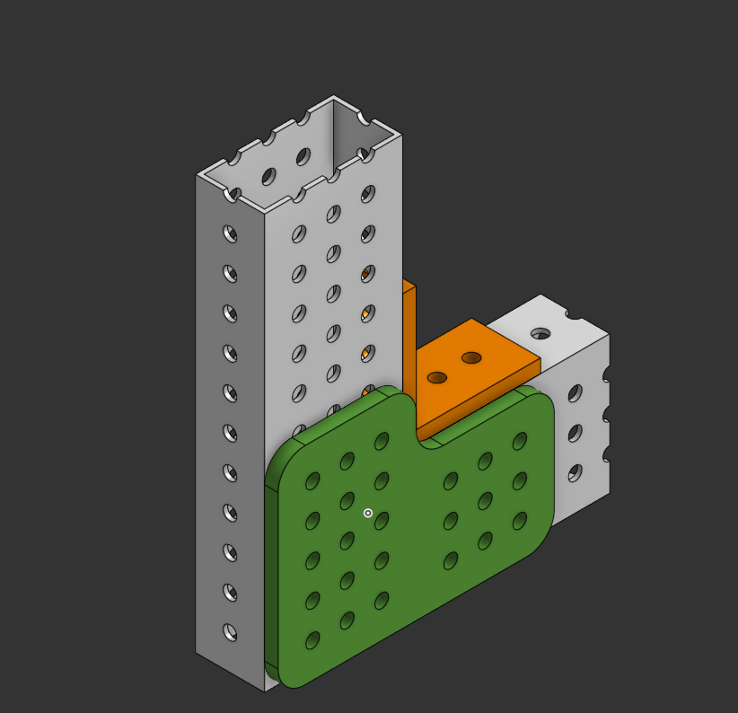
- (C) most elegant (looks)
examples


Lesson 3: Multi-Part Part Studios
Goals: To teach students how to design multiple related parts within a single Onshape Part Studio while integrating FRC-specific design tools.
Min 0-30: WCP Gear Calculator:
The students will get to know the site “WCP Gear Calculator” and learn how to find the center distance for two gears. The students (together with the instructor) will sketch a gear relation of 3-4 gears, all of different teeth, on the same “plate”.
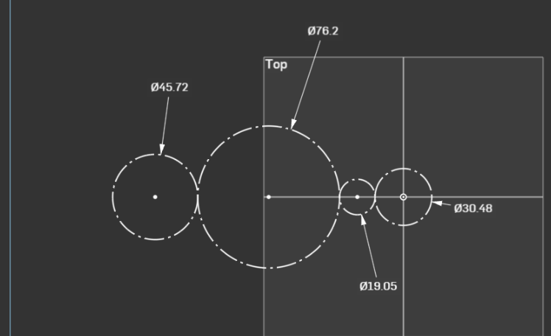
Min 30-60: Gearbox Plate Design:
The students will have to model a plate for a gearbox with a gear ratio of their choice, with holes for future spacers. The plate has to include enough space so the spacer will not hit the gears.
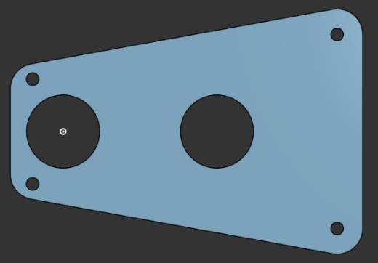
Min 60-90: Multi Part Part Studios:
The student will learn about the extrude-add feature, how to design based on the inside shape and how to take dimensions based on other parts in the part studio.
In addition the the teacher will talk about the importance of material distribution when lightening a part.
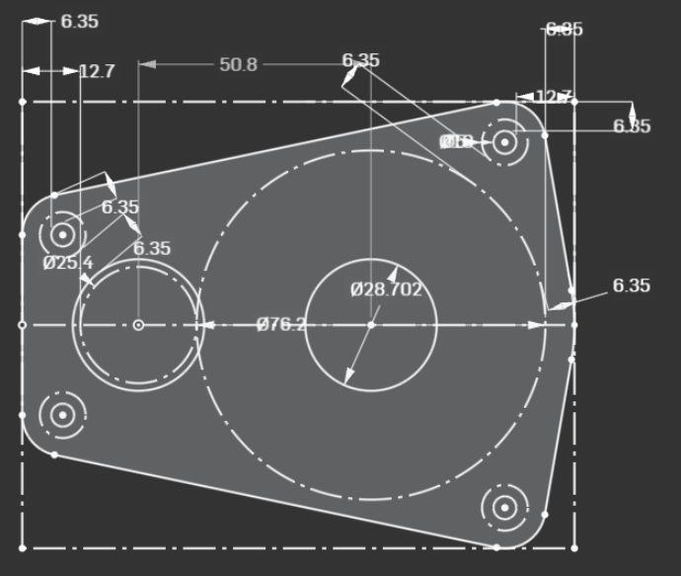
Min 90-120: The Gearbox Gladiators
The teacher will give the students a gear ratio (eg. 36:24, 85:15) and the student will need to model a gearbox (2 plates with spacers), the lighter the better, but there’s also importance to weight
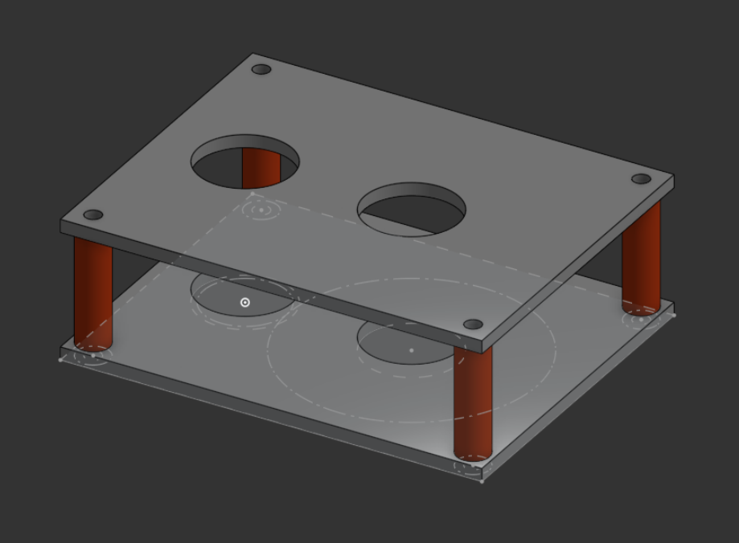
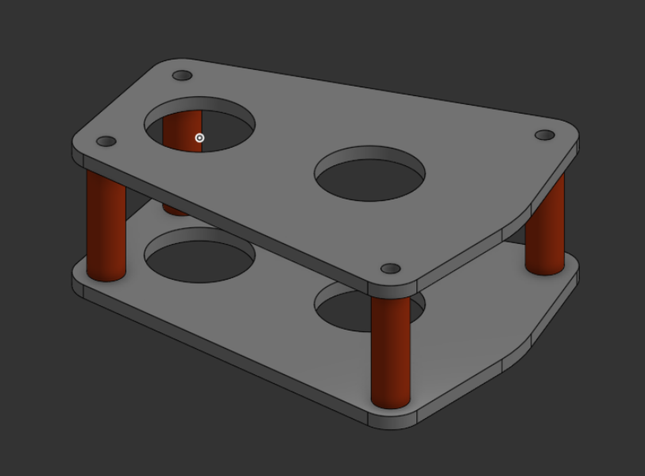
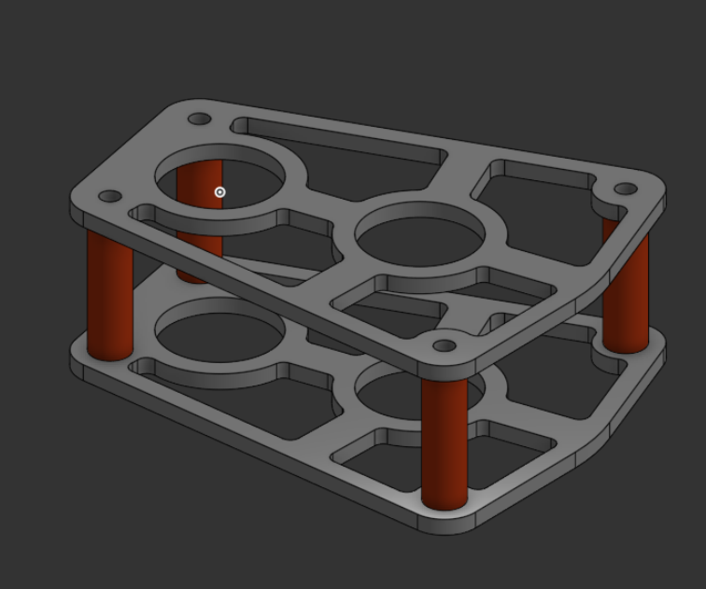

Lesson 4: Basic Assembly and COTS
Min 0-30: Inserting and basic mates:
The students will learn about the assembly tab, how to add part to the assembly, the concept of fixing, and Fastend/Revolute mates.
Min 30-60: Fixing the gearbox (L3 comp):
The students will insert the gearbox from the end of the last lesson and will need to use the assembly features to completely fix it in place.
Min 60-90: FRCDesignDeriver, COTS and mate connectors
The student will get to know the FRC design addon, how to download it, use it, and what are mate connectors
Min 90-120: Gearbox ASSEMBLE(y):
The students will be given the task to insert bearings, gears and shafts from FRC design to the fixed assembly and to use Fastend and Revolute mates to fill the gearbox as designed.
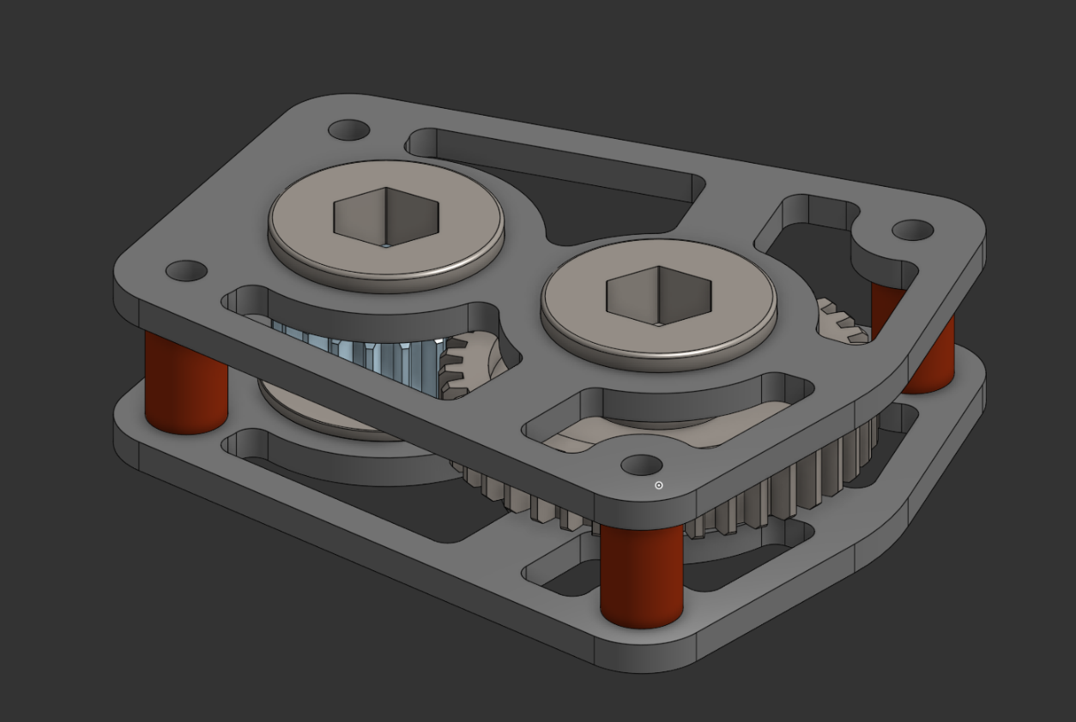

Lesson 5: Advanced Assembly and “webbing around”
Min 0-30: More mates! (why can’t I find one…)
Mates learned:
- Slider
- Planar
- Parallel
- Cylindrical
- Group
- Gear relation
Min 30-60: Parallel lock:
The students will be tasked to model a cube, insert it into the assembly and fix it to the origin using only planar mates
Bonus mission: add a hole to the cube and make another cube that has a fighting bump and connect them together using only planar mates.
Min 60-90: Finding data online and useful sites - FRCDesign
The students will get to know the site behind the FRCDesignApp - FRCDesign and will look at the systems.
Min 90-120: Kahoot!
The students will participate in a Kahoot where they will be shown pictures of connections and will need to answer which mate fits the most in the situation:
https://create.kahoot.it/share/lesson-5/2166007a-13fe-4631-9d0a-abf0e27f7fdd

Lesson 6: Assembly Context
Min 0-30: Edit in context:
The students will learn about “the edit in context” feature and the meaning of “create new context” by creating a new assembly and entering a motor into it, then modelling a plate that fits on the motor’s mounting holes.
Min 30-60: adding a motor to prior assemblies:
The student will be given the task to add shafts and a motor to the assembly from lesson 4, then modelling another plate to place the motor on that connects via spacers.

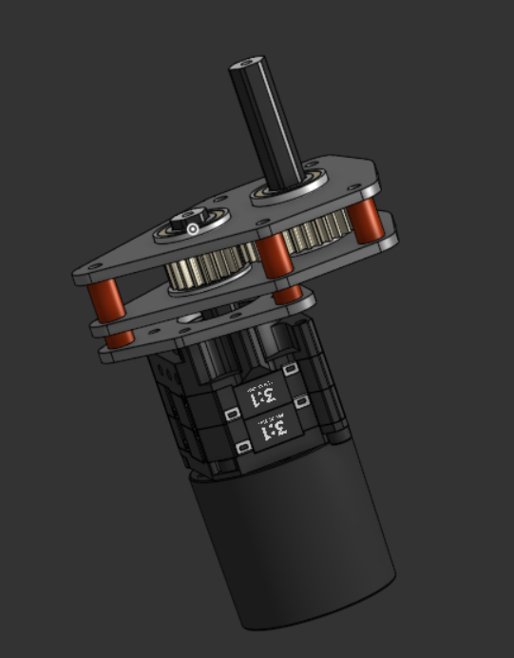
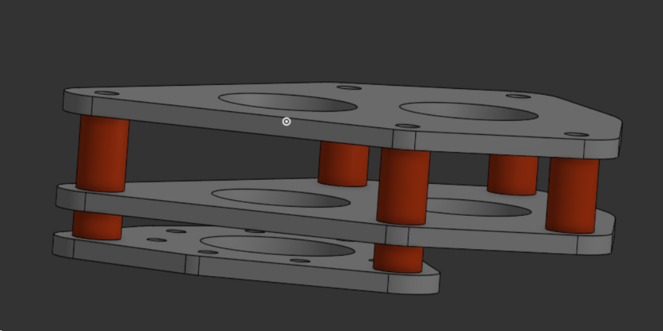
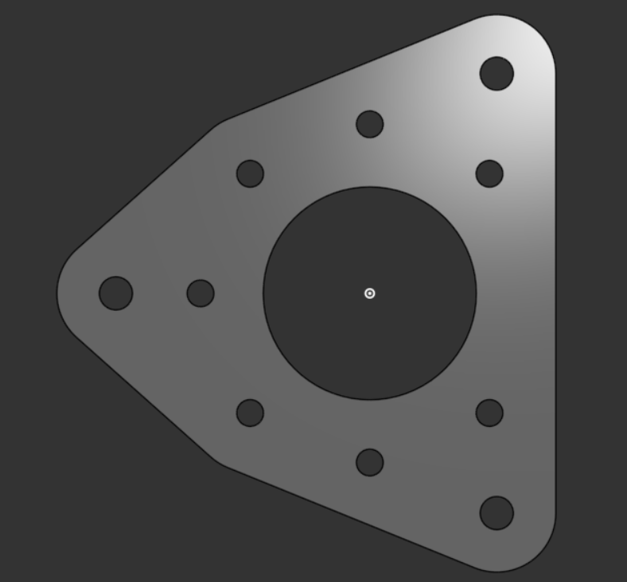
Min 60-90: Create part studio in context:
The student will learn about the “Create part studio context” feature and picking an origin point.
Min 90-120: The Missing Plate
The students will be given the following link to an Onshape file
https://cad.onshape.com/documents/93bfbecb55d6fc30f477e54a/w/e640265bfc0b335922454740/e/2f59f5cb8a54034be4edb60b?renderMode=0&uiState=6a0dec393f317a82c57050ba
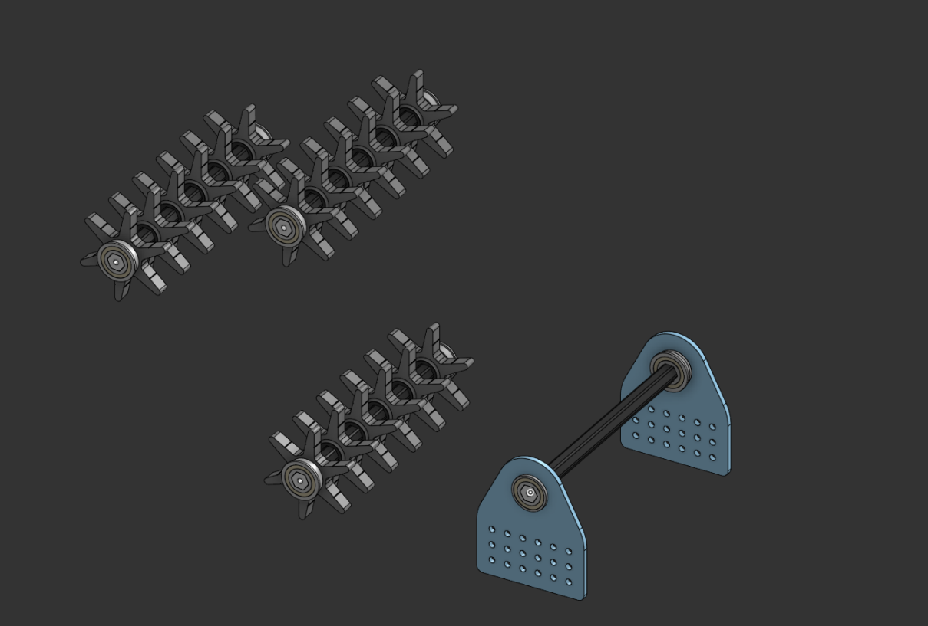

The file will include the following assembly and the students will be tasked with creating a plate for the intake that will connect to the base (blue plate) and will hold all 3 shafts.
The first to complete this mission wins the competition.
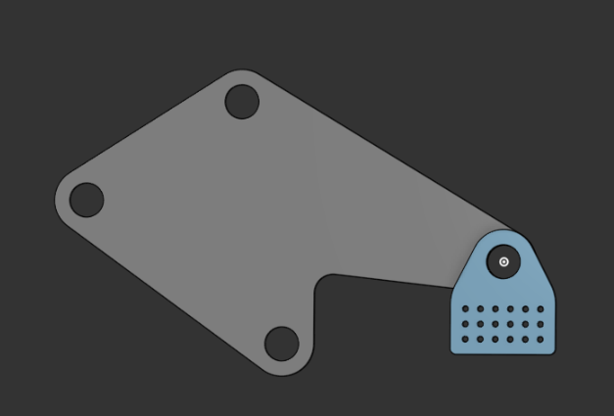 example plate


Lesson 7: Custom Features and variables
Min 0-30: Introduction to custom features - lighten
The student will learn to add custom features and will add the lighten feature and will learn how to use it, the part from lesson 6 competition can be used as an example.
Min 30-60: Shopping cart
The students will get 30 minutes to find at least 5 interesting custom features (the more the better) and show them to the rest of the class.
Min 60-90: Variable studio and parametric modeling
The students will learn about variable studios and global variables and how to use them. *The teacher should use the lighten and other custom features together with variables as examples for variable studio.
Min 90-120: Design battle All-V-All:
The students will compete on who can design the most complex (usable) system under these conditions:
- No sketches or extrudes - only part from features.
- All Meaningful values have to be defined as variables.
- Less variables is better.
- All dimensions sharing a variable need to have meaningful relations.

4:
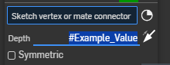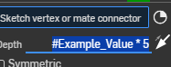 GOOD

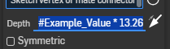 BAD

Lesson 8: Master Sketch and THE Grand Finale
This lesson works a bit differently: The first 30 minutes are dedicated to learning and then the rest of the lesson will be a duo mission.
Min 0-30: Master sketching
The students will work with a guided example on how to calculate dimensions and predefine the sizes and shapes accordingly.
Recommended example: 2026 intake plate:
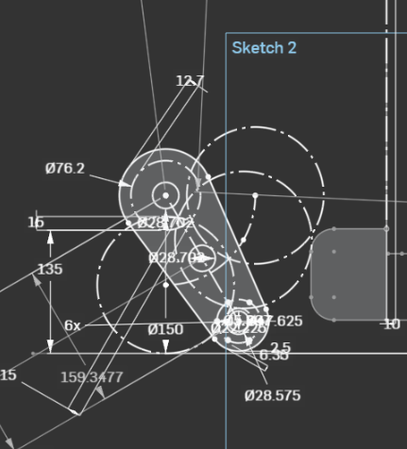
Min 30-120: Duo Design Dance-off
The students will divide into groups of 2 and will compete on who can design the best pivoting intake the fastest. The design will include complete part studios and assembly of the system.

